SCR results for year-end 2025
1. Introduction
1.1 Overview
This report summarises the Solvency Position of Smart Insurance Ltd (the Company) for year-end 2025 with comparison to the previous year-end.
The Solvency Ratio decreased by 10.5% from 152.6% to 142.1% since the previous year. Analysis of the drivers of the results is provided in Section 2.
1.2 Background
The capital regime for an insurance undertaking in the EU is governed by the Solvency II Directive. This directive requires insurance undertakings to report their solvency to the supervisory authorities on a regular basis, typically quarterly or annually.
1.3 Scope
The scope of this report covers the annual results of Smart Insurance Ltd in terms of:
- Solvency Capital Requirement (SCR)
- Own Funds
- Solvency Ratio
2. Results
Table 1 below summarises the solvency position of the entity for year-end 2025.
Table 1 – Summary of Solvency Position 2025 vs 2024
€m | 2025 | 2024 | Movement | Movement %
Market | 110.3 | 100.0 | 10.3 | 10.3%
Counterparty Default | 60.5 | 50.5 | 10.0 | 19.8%
Life | 75.3 | 80.3 | -5.0 | -6.2%
Health | 62.2 | 55.3 | 6.9 | 12.5%
Diversification | -61.7 | -78.0 | 16.3 | -20.9%
Basic SCR | 246.6 | 208.1 | 38.5 | 18.5%
Operational Risk | 21.5 | 19.9 | 1.6 | 8.0%
Deferred Tax Adjustment | -33.5 | -31.1 | -2.4 | 7.7%
Total SCR | 234.6 | 196.9 | 37.7 | 19.1%
Own Funds | 333.3 | 300.5 | 32.8 | 10.9%
Solvency Ratio | 142.1% | 152.6% | -10.5% | -6.9%
The table shows that:
- The Total SCR increased by 19.1% from €196.9m to €234.6m since the previous year.The largest contributor to the increase in the Total SCR by €37.7m is the increase in €1.6m by Operational Risk risk.
- The Own Funds increased by 10.9% from €300.5m to €333.3m since the previous year.
- The Solvency Ratio decreased by 10.5% from 152.6% to 142.1% since the previous year.
- The Market, Counterparty Default, Health BSCR increased over the year but Life BSCR decreased.
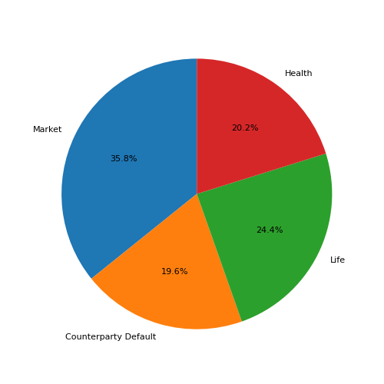
Figure 1: Composition of the Basic SCR - 2025
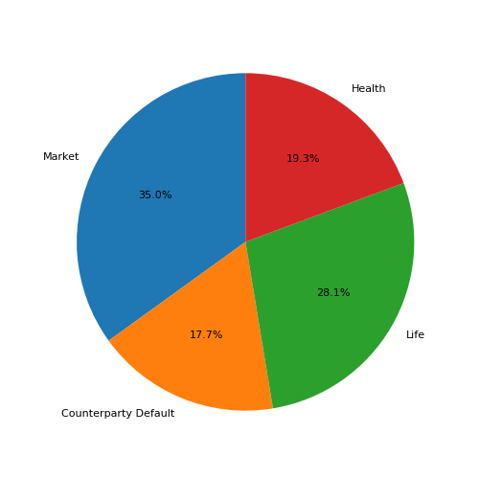
Figure 2: Composition of the Basic SCR - 2024
The proportion of Market, Counterparty Default, Health BSCR increased over the year but proportion of Life BSCR decreased. The increase in Life and Health risks is due to growth in business volume. Most of the growth came from Health Risks due to the introduction of a new product called ProtectMe.
3. Conclusion
The Company's solvency ratio of 142.1% is above its target of 125.0%.

